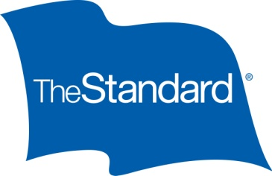
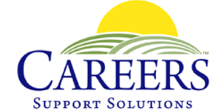

Labels Campaign Sparks Conversations About
Difficulties Individuals With Disabilities Face in the Workplace
The Standard and CAREERS Support Solutions seek to ensure every employee can be successful

PORTLAND, OREGON — Aug. 29, 2017 — Standard Insurance Company (The Standard) continues its campaign to help employers understand the importance of addressing stigmatizing labels that people with a disability, illness or chronic condition may be subject to in the workplace. Recently, The Standard partnered with CAREERS Support Solutions, a nonprofit that empowers people with disabilities to achieve meaningful employment.

At the 2017 SHRM Annual Conference & Exposition, The Standard and CAREERS Support Solutions partnered on a word cloud activity to start a conversation about the labels that many individuals with disabilities face in the workplace. The Standard asked the conference’s 15,000 attendees to submit examples of labels they’re working to overcome in their own organizations. This interactive booth activity ran in conjunction with a donation from The Standard to help CAREERS Support Solutions fund supportive services for individuals experiencing similar workplace challenges.

“The Standard has been a strong corporate supporter of CAREERS Support Solutions, so we were thrilled to be included as a partner for their ‘Labels’ campaign,” commented Tina Cornish-Lauria, executive director at CAREERS Support Solutions. “This enlightening project spotlights the difficulties we often face when searching for jobs for individuals with disabilities. Erasing negative labels allows the many positive characteristics that these employees bring to the workforce to be highlighted, including enthusiasm, loyalty and appreciation for the chance to be part of the workplace team. We are very grateful to The Standard for spearheading this insightful project as well as their ongoing and generous support.”

The Standard launched the campaign to help employers understand the importance of addressing the labels that people with a disability, illness or chronic condition may be subject to in the workplace. The campaign discusses how employees often feel labeled by their medical condition, thinking that others — including fellow co-workers or managers — believe that they are unproductive or that accommodating them could be too costly. Solutions from The Standard are designed around a proactive approach to disability management to help erase these unfair impressions and provide practical assistance to help with an employee’s stay-at-work or return-to-work accommodation.

“Our campaign brings attention to the labels that are so often unfairly put on employees, but then proves those labels wrong and celebrates the idea that every employee can be successful,” said Bob Speltz, senior director of Public Affairs at The Standard. “The Standard is focused on helping people achieve financial well-being and peace of mind, and CAREERS Support Solutions executes on that with its daily work. This corporate partnership and philanthropic donation to CAREERS Support Solutions is a way for us to show our support of its worthy work.”

For more information on CAREERS Support Solutions, please visit careerssupportsolutions.org.

###

About The Standard
The Standard is a leading provider of financial products and services, including group and individual disability insurance, group life and accidental death and dismemberment insurance, group dental and vision insurance, absence management services, retirement plans products and services and individual annuities. For more information about The Standard, visit www.standard.com.
The Standard is a marketing name for StanCorp Financial Group, Inc., and subsidiaries. Insurance products are offered by Standard Insurance Company of 1100 SW Sixth Avenue, Portland, Oregon, in all states except New York, where insurance products are offered by The Standard Life Insurance Company of New York of 360 Hamilton Avenue, Suite 210, White Plains, New York. Product features and availability vary by state and company, and are solely the responsibility of each subsidiary. Each company is solely responsible for its own financial condition. Standard Insurance Company is licensed to solicit insurance business in all states except New York. The Standard Life Insurance Company of New York is licensed to solicit insurance business in only the state of New York.

About CAREERS Support Solutions
CAREERS Support Solutions’ mission is to empower people throughout Westchester and Putnam counties, New York, to achieve the satisfaction of meaningful employment. They prepare people with disabilities and/or low socioeconomic status for employment by teaching workforce readiness skills and providing job placement, on-the-job training and ongoing support to assure long-term success at no cost to the individual or employer. For information on CAREERS programs for individuals with disabilities, please visit www.careerssupportsolutions.org or friend them on Facebook at http://www.facebook.com/CAREERSforPeople.

CONTACTS

General Media
Bob Speltz, The Standard
971.321.3162
bob.speltz@standard.com

Trade Media
Cassandra Bergemann, Bader Rutter (on behalf of The Standard)
262.938.5461
cbergemann@bader-rutter.com

Local Media
Christine Chenevey, CAREERS Support Solutions
914.741.5627
proutreach@aol.com

