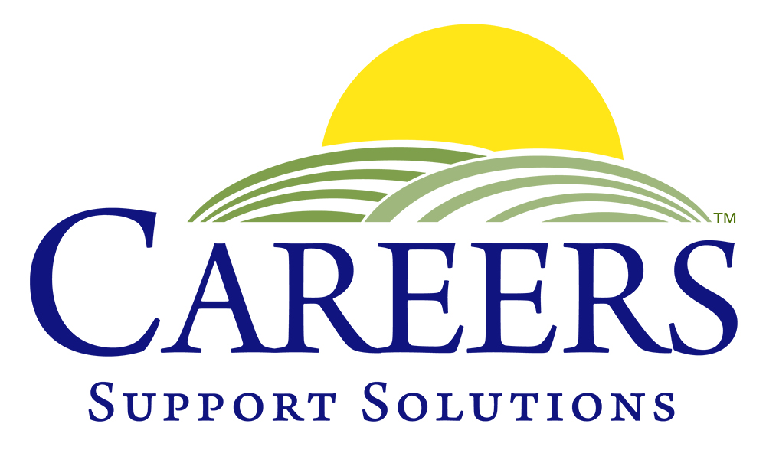
401 Columbus Avenue, Valhalla, NY 10595
(914) 741-8500 Fax: (914) 741-6865

102 Gleneida Avenue, Carmel, NY 10512
(845) 225-8007 Fax: (845) 225-6820

careersforpeople@aol.com

www.careerssupportsolutions.org

NEWS RELEASE

FOR IMMEDIATE RELEASE Contact: Christine Chenevey
January 23, 2017 Phone: 914-741-8500, ext. 102
E-mail: PROutreach@aol.com
_____________________________________________________________________________

CAREERS Support Solutions – New Name for Job Placement Non-Profit

Valhalla and Carmel, New York – January 23, 2017 – CAREERS Support Solutions is the new name of the 30-year old non-profit organization formerly known as CAREERS for People with Disabilities. The organization continues to provide job training, placement and ongoing support for individuals with disabilities in Westchester and Putnam Counties.

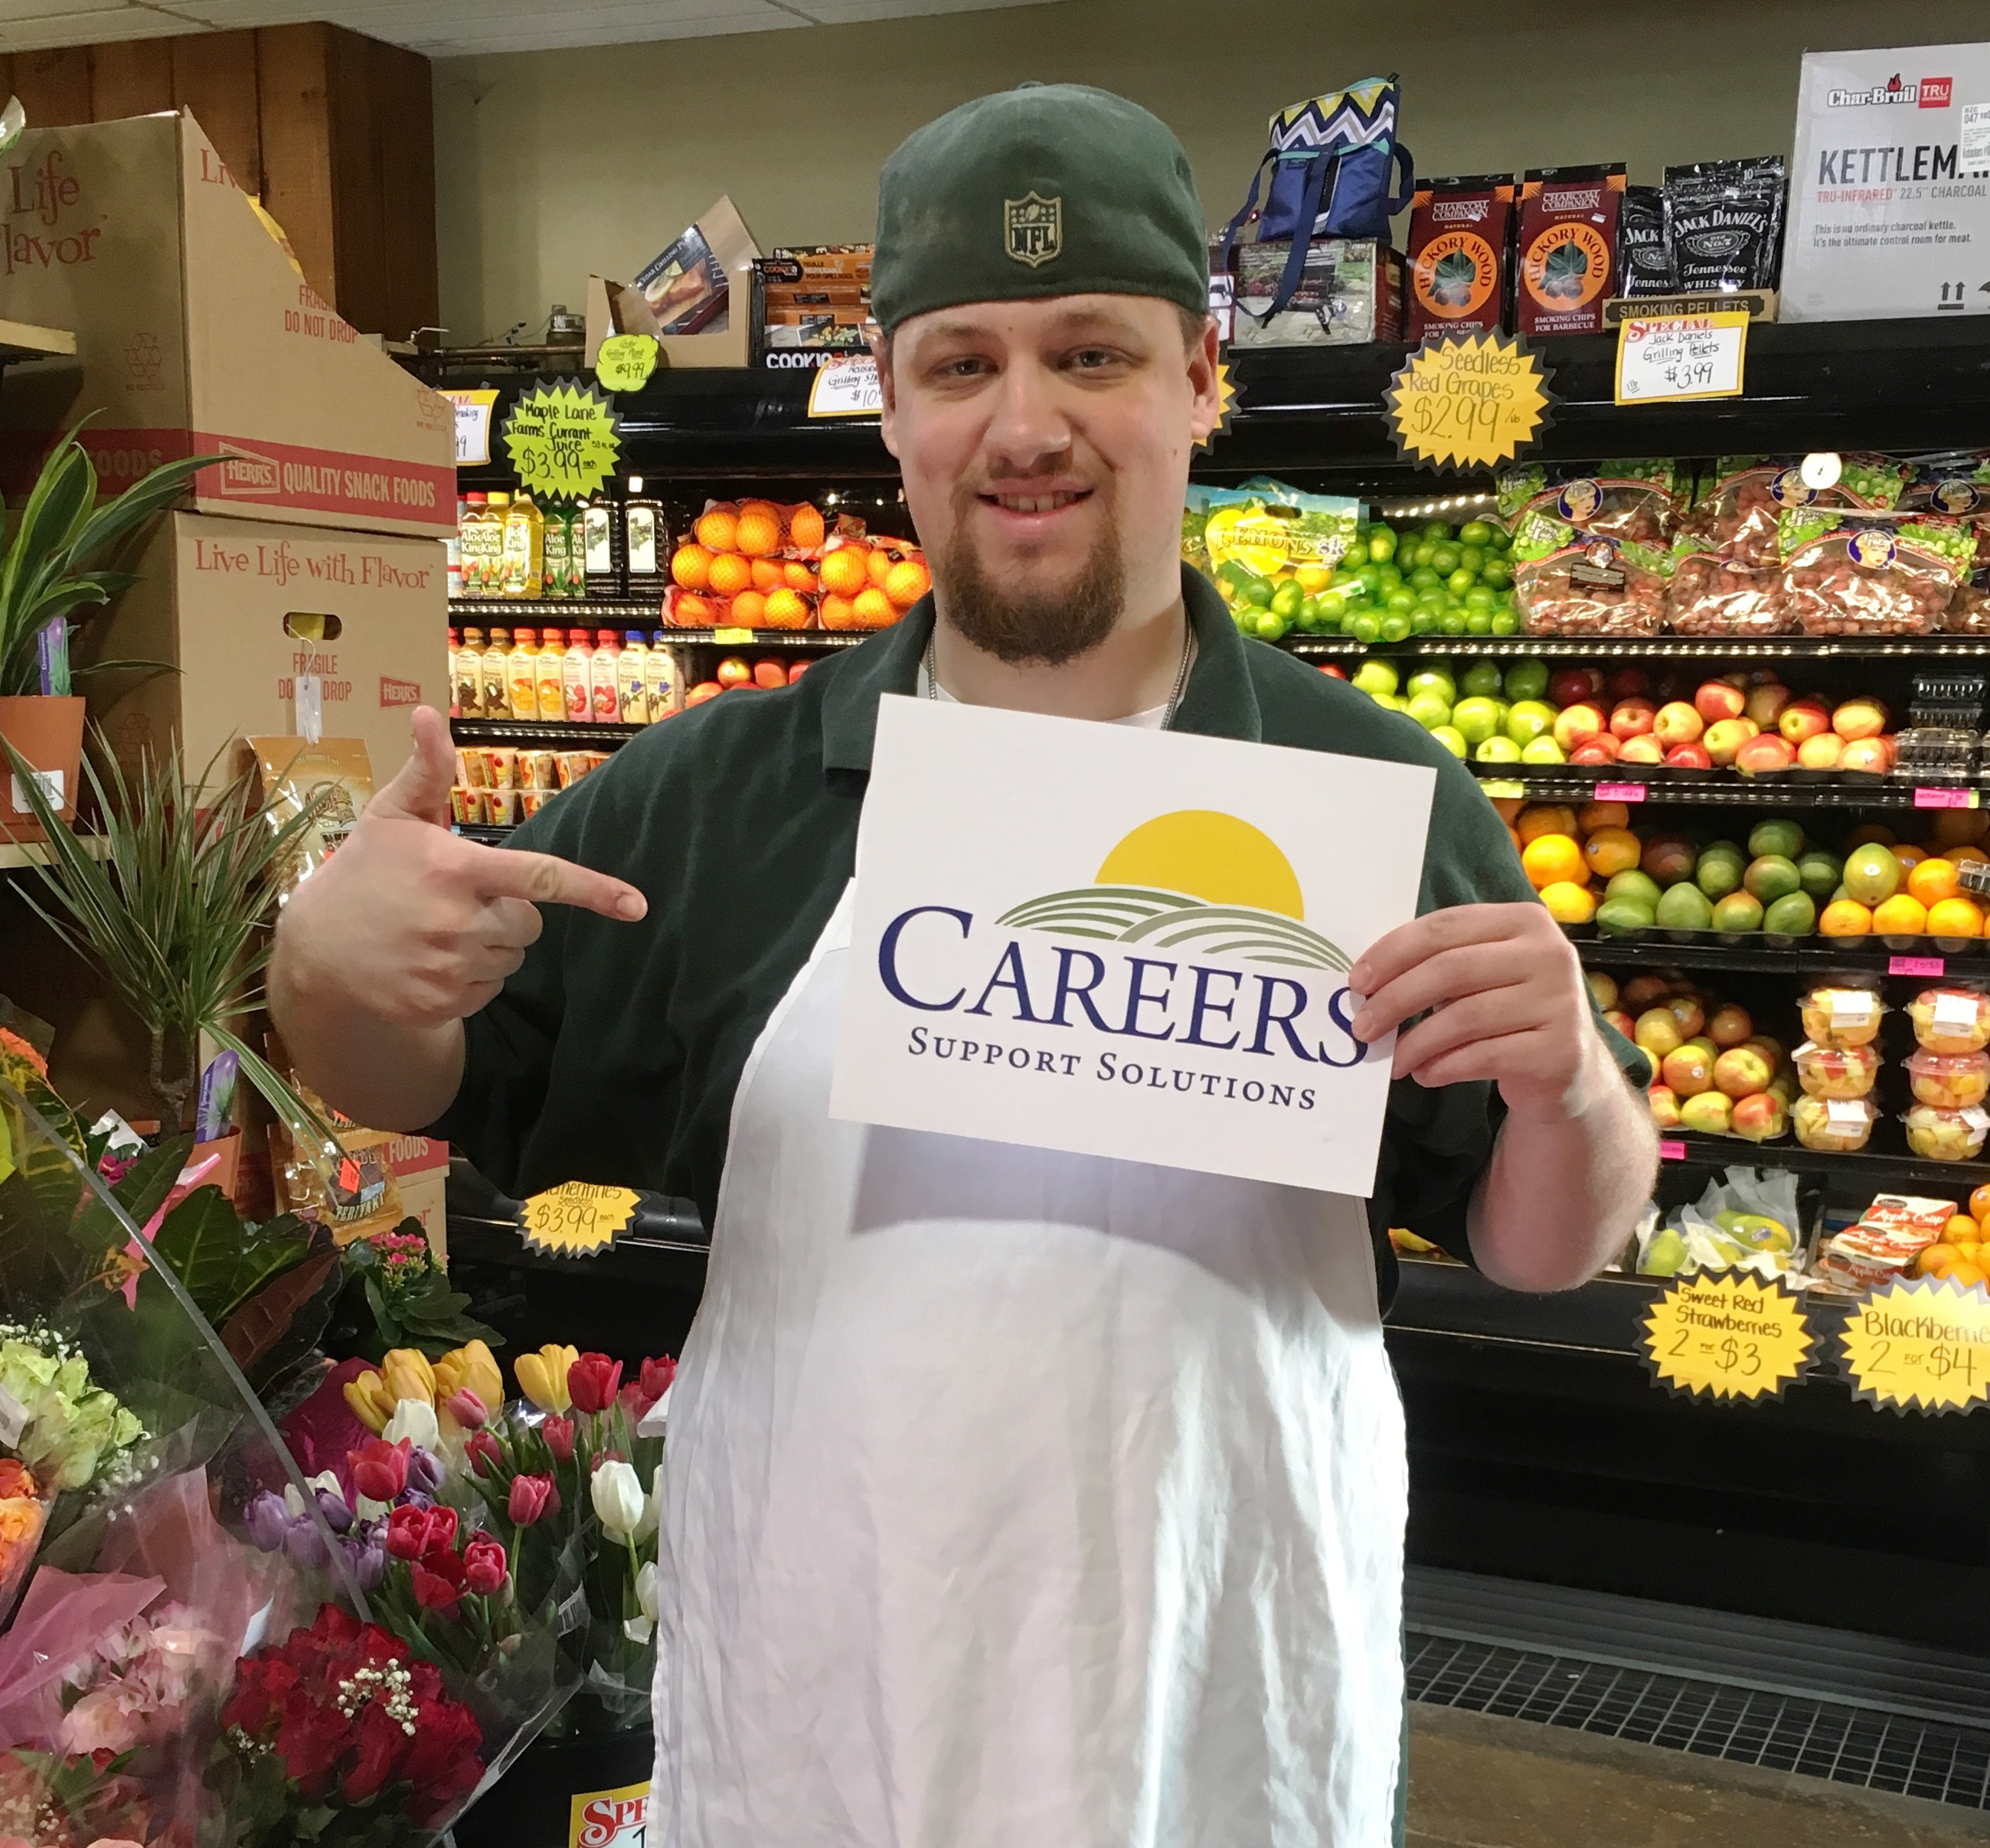
“Although our name is changing after 30 years, our mission of empowering individuals who want to work has not”, explained Tina Cornish-Lauria, CAREERS Executive Director. “Our professional staff provides personalized support to our clients and personnel solutions for our employers, and our new name highlights that win-win relationship. It also reflects our expansion in providing employment training and placement to low-income, long-term unemployed individuals who have fallen through the cracks and are not able to find an appropriate job on their own,” Ms. Cornish-Lauria said.

Since 1987, CAREERS has made over 2,500 job placements and provided support services to well over 6,000 people with disabilities in Westchester and Putnam Counties. In 2016, they placed over 115 individuals in new jobs and more then 40 in internships.

CAREERS Support Solutions mission is to empower people throughout Westchester and Putnam Counties, New York to achieve the satisfaction of meaningful employment. They prepare people with disabilities and/or low socioeconomic status for employment by teaching workforce readiness skills and providing job placement, on-the-job training, and ongoing support to assure long-term success – at no cost to the individual or employer.
CAREERS client Stephen Booth, who works at Kobacker’s Market in Brewster, helps launch CAREERS new name.

For information on CAREERS programs for individuals with disabilities or employers in need of qualified help, contact CAREERS’ Valhalla office, which serves central and lower Westchester at (914) 741-8500, or the Carmel office, which serves northern Westchester and Putnam Counties, at (845) 225-8007. For more information, please visit www.careerssupportsolutions.org, or friend us on Facebook at http://www.facebook.com/CAREERSforPeople.

# # #

