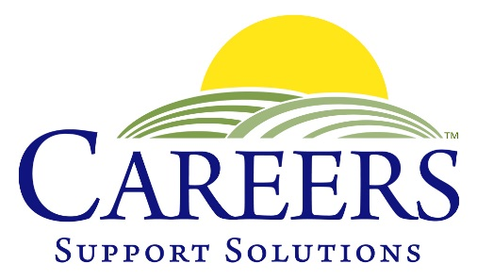
400 Columbus Avenue, Valhalla, NY 10595

(914) 741-8500

102 Gleneida, Carmel, NY 10512

(845) 225-8007

www.careerssupportsolutions.org

NEWS RELEASE

FOR IMMEDIATE RELEASE Contact: Christine Chenevey
Phone: (914) 741- 8500
May 22, 2019 E-mail: CChenevey@careersfp.org
_____________________________________________________________________________

Putnam County 8th Annual Mentoring Day

Carmel, New York, May 22, 2019 …. Learning by doing made for a successful 8th Annual Mentoring Day, a collaboration with CAREERS Support Solutions (CAREERS) and Putnam County government. Mentors from County Departments were paired with students and adults with disabilities who are interested in learning the skills they need to be successfully employed.

On the morning of May 22nd, participants from CAREERS, Carmel High School and The ARC of Putnam were welcomed to Cornerstone Park in Carmel to meet their mentors. Matched by their interests and abilities, they then spent the morning with county staff from Departments including the Health Department, IT, Youth Bureau, Senior Resources and Probation. Working with and learning from their mentors, they learned organizational, computer and administrative skills, customer service and maintenance.

“We so appreciate the effort County Executive Odell and her staff put into this event,” remarked CAREERS Executive Director Tina Cornish-Lauria. “Last year, one of our participants was offered a part time job from the department he was working in on Mentoring Day, and he had a great experience working there after the event,” Cornish-Lauria said.

“Putnam is a community that cares, and we are proud to participate in this event each year. It’s really great to see many familiar faces that come back,” County Executive Odell remarked to those gathered in Cornerstone Park for the wrap up of the event, where mentors and mentees received Certificates of Appreciation.

About CAREERS Support Solutions, Inc.
Since 1987, CAREERS has provided job placement and support services to people with disabilities in Westchester and Putnam Counties, and provided services to over 2,700 individuals with disabilities. CAREERS’ mission is to insure that all individuals with disabilities find sustained, meaningful employment in the communities in which they live. We work one-on-one with each client and employer to facilitate ongoing success in the workplace and help those with disabilities reach their maximum level of self-support and self-reliance. All of CAREERS’ services are provided free of charge to individuals and their families, as well as employers.

For additional information about how CAREERS helps individuals with disabilities and low-income, long-term unemployed, as well as employers in need of qualified help, contact CAREERS’ Carmel office, which serves northern Westchester, Putnam and lower Dutchess Counties, at 845-225-8007. For more information, please visit www.careerssupportsolutions.org.

# # #

