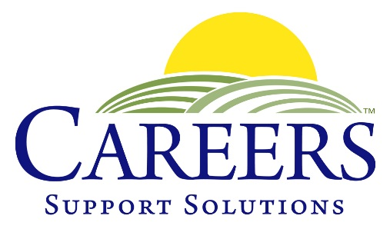
400 Columbus Avenue, Suite 123 South, Valhalla, NY 10595
(914) 741-JOBS

102 Gleneida Avenue, Carmel, NY 10512
(845) 225-8007

www.CAREERSSupportSolutions.org

NEWS RELEASE

FOR IMMEDIATE RELEASE Contact: Nancy Coveney
July 27, 2021 Phone: 914-741-JOBS (5627)
Email: proutreach@aol.com
_____________________________________________________________________________

CAREERS Support Solutions Receives NYS Empire Award

July 27, 2021, Carmel, NY – CAREERS Support Solutions received the New York State Empire Award, dedicated for organizations who have made a significant contribution for the betterment of their community. To mark Disability Pride Month, State Senator Pete Harckham honored CAREERS, a private, nonprofit that provides long-term jobs and ongoing support for people with developmental, emotional and physical disabilities in Westchester, Putnam and Dutchess Counties.

Senator Harckham explained that CAREERS was chosen for the award because “their programs meet an individual’s unique needs and places them in jobs based on their abilities and interests. They provide on-the-job training and long-term support for as long as each individual requires.”

Tina Cornish-Lauria, Executive Director of CAREERS, accepted the award in a Zoom presentation honoring community members who have made contributions to enhance the lives of individuals with disabilities.

“We think it’s significant that Title 1 of the Americans with Disabilities Act focuses on employment and prohibits employers from discriminating against qualified individuals who have a disability,” Cornish-Lauria remarked. “Our goal at CAREERS is not only to help those with disabilities find and keep jobs they love, but to educate employers and the public about the benefits of hiring individuals with disabilities. Our sincere thanks to Senator Harckham for highlighting the work we have done with pride for 34 years”

CAREERS Support Solutions provides support services to hundreds of program participants annually throughout Westchester, Putnam and Dutchess Counties. CAREERS mission is to empower people with disabilities by teaching workforce readiness skills and providing job placement, on-the-job training, and ongoing support to assure long-term success – at no cost to the individual or employer. For more information visit www.careerssupportsolutions.org .
###

