Happening Now

CAREERS Opens a Thrift Shop!

CAREERS Support Solutions opened a new Thrift Shop in Carmel to help fund our supported work programs for people with disabilities. It’s also a great way for our clients, like the guys from the Ambition In Motion program pictured here, to learn job skills ….. Read more

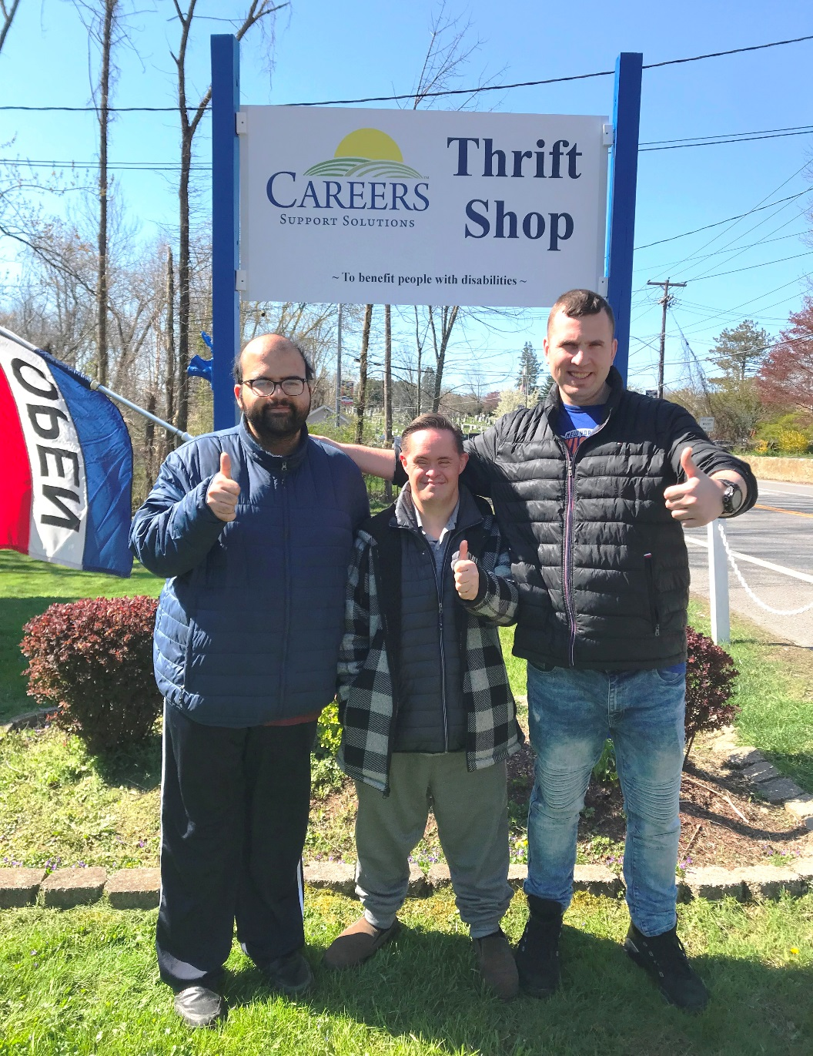

CAREERS Support Solutions opened a Thrift Shop at 208 Route 52 in Carmel, which is open from 11 a.m. to 3 p.m. Tuesday through Saturday. The shop is run by volunteers and helps our clients, like the guys from our Ambition In Motion (AIM) program pictured, get some hands-on jobs skills training. The shop will eventually provide paid internships to CAREERS clients and proceeds will help fund CAREERS programs of job training and placement for individuals with learning, intellectual, developmental, psychiatric and/or physical disabilities.

Tina Cornish-Lauria, Executive Director of CAREERS, said the new shop is within walking distance from ShopRite. “This is a great opportunity for CAREERS clients to learn retail skills such as stocking shelves, customer service and using a cash register. The shop will also allow us to provide work try-outs for students, to see where their skills and interests lie,” she explained. “We look forward to showing the public how people with disabilities perform necessary roles in the workplace and become valued team members.”

The shop accepts donations of gently used women’s and men’s clothing, shoes, jewelry, handbags, household goods, linens, pet necessities, and other items, keeping them out of landfills while providing unique and affordable treasures to all members of the community. We cannot accept children’s clothing, bathing suits, appliances, computers, books, video games, CDs, DVDs, toys, stuffed animals, musical instruments and sporting goods. All purchases and donations are tax deductible as allowed by law.

The new Thrift Shop is a great place for volunteers like Sherrill Doar (pictured here with CAREERS Executive Director Tina Cornish-Lauria) to keep busy during retirement. “I am truthfully having a ball volunteering my time here,” Doar told the Putnam County Courier. “Our customers are lovely and we really have some great buys for the public.”

