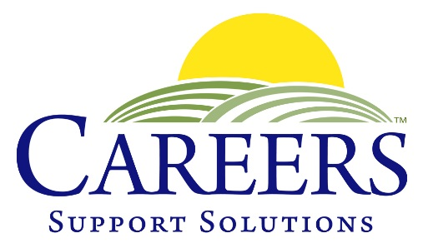
400 Columbus Avenue, Suite 123 South, Valhalla, NY 10595
(914) 741-JOBS

102 Gleneida Avenue, Carmel, NY 10512
(845) 225-8007

www.CAREERSSupportSolutions.org

NEWS RELEASE

FOR IMMEDIATE RELEASE Contact: Nancy Coveney
March 15, 2023 Phone: 914-741-JOBS (5627)
Email: proutreach@aol.com
_____________________________________________________________________________

Three New Board Members Join CAREERS Support Solutions

March 13, 2023, Valhalla, NY – Three new members have joined the Board of Directors of CAREERS Support Solutions, a private non-profit that provides job training and placement for individuals with learning, intellectual, developmental, psychiatric and/or physical disabilities. CAREERS welcomes banker Erik Martin; special education advocate and attorney Alison Morris; and human resources director Melissa Strauss to the board.

Tina Cornish-Lauria, Executive Director of CAREERS, said the organization’s Board of Directors are all volunteers who oversee the agency. “The board serves a vital role in governing CAREERS,” she said. “We are fortunate to attract people with different professional backgrounds to serve in our mission to help people with disabilities achieve their greatest potential. We are delighted to welcome Erik, Alison and Melissa. Their expertise and talent are wonderful additions to the board.”
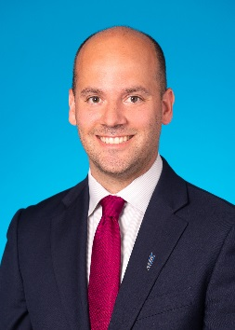
Erik Martin is a vice president of City National Bank in Manhattan, specializing in relationship management. In his 20-year career in the financial industry, Erik took on greater levels of responsibility in creating a customized banking experience and tailored financial approach, recruiting and retaining high net worth individuals and business owners at Wells Fargo Bank and Citibank. He managed and established a team of professionals to create financial strategies for short and long term goals for each client. Erik has a bachelor’s degree in Business Management from Dowling College and is heavily involved in community outreach. He volunteers for White Plains Youth Football and White Plains Little League.

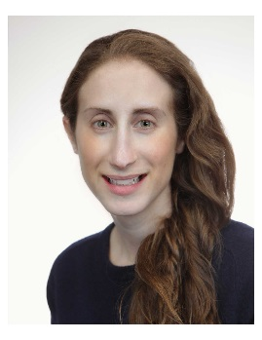
Alison Morris, Esq. is a senior attorney with the Cuddy Law Firm’s Valhalla office. Alison practices special education advocacy and litigation at the Cuddy Law Firm. She represents families and children with special education needs at IEP and Section 504 meetings, and represents families in due process hearings when families challenge the decisions made by school districts, many from underserved populations. Alison also assists clients in navigating the OPWDD system including helping with applications and appeals. Ms. Morris is a frequent lecturer on topics of interest to professionals and families on special education law, and she is also an Adjunct Professor at Pace Law School, teaching a course entitled Law and Education. Ms. Morris also Co-Chairs both the New York State Bar Association’s Committee on Disability Rights and the Westchester Women's Bar Association’s Education Committee. Alison is the proud sister of a young adult with special needs.
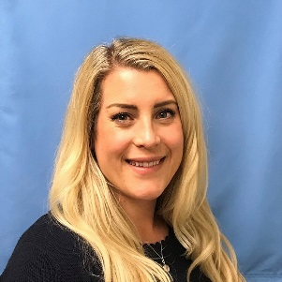
Melissa Strauss is the Senior Director of Human Resources at RWE Clean Energy in Valhalla. She is a dedicated and certified human resources professional with knowledge and experience handling various human resource functions within multiple industries. Melissa has over 8 years of experience in the areas of HR. She has PHR and SHRM-SCP certifications and has a bachelor’s degree in Education from the University of Wisconsin-Eau Claire and M.B.A. in Human Resource Management from Iona University. Melissa plays a dynamic role in the Westchester community through volunteer work and is actively involved in organizations such as the Junior League of Northern Westchester, the Westchester Human Resource Management Association as President of the Board, and a member of the Business Council of Westchester. Melissa is the recipient of the 2022 Rising Stars 40 Under 40 Award.
Since 1987, CAREERS Support Solutions has provided services to hundreds of students and adults annually throughout Westchester, Putnam and Dutchess Counties. CAREERS mission is to empower people with disabilities by teaching workforce readiness skills and providing job placement, on-the-job training, and ongoing support to assure long-term success – at no cost to the individual or employer. For more information visit www.careerssupportsolutions.org or call (845) 225-8007.

